**UNIT I INTRODUCTION 9**

An Introduction to Knowledge Management - The foundations of knowledge management- including cultural issues- technology applications organizational concepts and processes- management aspects- and decision support systems. The Evolution of Knowledge management: From Information Management to Knowledge Management - Key Challenges Facing the Evolution of Knowledge Management - Ethics for Knowledge Management

**AN INTRODUCTION TO KNOWLEDGE MANAGEMENT:**

**WHAT IS KNOWLEDGE?**

* It is different from data & information
* Knowledge is at the highest level in a hierarchy with information at the middle level, and data to be at the lowest level
* It is the richest, deepest & most valuable of the three
* Information with direction, i.e., leads to appropriate actions

**WHAT IS KNOWLEDGE MANAGEMENT?**

* + - (KM) may be defined simply as doing what is needed to get the most out of knowledge resources.
    - (KM) focuses on organizing and making available important knowledge, wherever and whenever it is needed.
    - (KM) is highly related to the concept of intellectual capital (both human and structural.

**WHY KM IS IMPORTANT?**

Knowledge management provides benefits to individual, to communities of practice, and to the organization itself.

KNOWLEDGE MANAGEMENT

EXPLICIT KNOWLEDGE

TACIT KNOWLEDGE

KNOWLEDGE

INFORMATION

DATA

**DEFINITION:**

“Any structured activity that improves an organization’s capacity to acquire,share,and

Utilize knowledge in ways that improves its survival and success”

**BASIC DIFFERENCE BETWEEN TACIT AND EXPLICIT KNOWLEDGE:**

|  |  |
| --- | --- |
| **TACIT KNOWLEDGE** | **EXPLICIT KNOWLEDGE** |
| It is hidden and refers to intuitions experiences and insights. | Explicit knowledge can be articulated and codified items |
| Tacit knowledge dissemination is difficult and only happens through people | Explicit knowledge dissemination is easy and only happens through information technology |
| It is personal, and can be easily lost if the key people of organizations leave them | Explicit knowledge is impersonal, so it can be stacked through the organizational memories |
| It can be found in the form of values, ideas, beliefs, insight and innovation | It can be found in the form of rules, policies, researches and manuals . |

**FOUNDATION OF KNOWLEDGE MANAGEMENT:**

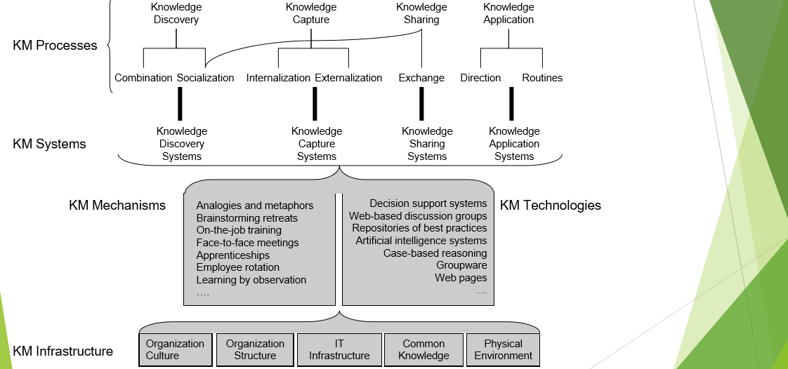

**ORGANIZATIONAL CONCEPTS AND PROCESS-INCLUDING CULTURAL:**

**ORGANIZATIONAL CULTURES:**

Organizational culture figures out values and beliefs which are an integral part of what one chooses to see and absorb. It comprises of a shared perception of reality, regarding how things are and how things should be. Furthermore, community and group culture determines the willingness and conditions for knowledge sharing with other members of the enterprise.

Thus, knowledge and knowledge sharing, are inseparable from organizational culture. The interface for culture is social interaction, the web of communications that constitute a community.

Organizational culture can also be described in terms of both its causes and effects. Using results perspective, culture can be defined as a manifested pattern of behavior, consistent behavioral patterns observed across a group of individuals, or “the way we do things around here.” So, culture deﬁnes consistent ways in which people perform tasks, solve problems, resolve conﬂicts, treat customers and employees, and so on.

Using a process perspective, culture is deﬁned as a set of mechanisms such as informal values, norms, and beliefs that control how individuals and groups in an organization communicate with each other and people outside the organization.

**DIFFERENT TYPES OF CULTURE:**

**Communal:**

It give its members a sense of belongingness, though it also is taskdriven. Leaders of this culture are basically very inspirational and charismatic. The drawback is that they often exert too much inﬂuence and other members are rarely vocal.

**Networked**:

Here, the members are treated as friends and family. People closely connect with each other and love each other. They are willing to help each other and share information. The drawback of this culture is that people are so kind to each other that they are reluctant to point out and criticize the poor performance.

**Mercenary**:

It focuses on strict goals. Here members are expected to meet the goals and to get the job done quickly. Since everyone aims on goals and objectivity, there is little room for political cliques. The drawback is that those with poor performance may be treated inhumanely.

**Fragmented:**

Here the sense of belongingness and identiﬁcation with the organization is usually very weak. The individualists comprise the organizations, and their commitment is ﬁrst towards individual members and task work. The drawback is that there is a lack of cooperation.

**CULTURE ANALYSIS:**

**Artifacts:**

These impersonate the visible elements such as processes, structures, goals, climate, dress codes, furniture, etc. A foreigner can see them but may not understand why things are the way they are.

**Espoused Values:**

The values are advocated by the leaders. They are mostly grounded in shared assumptions of how the company should be run. If there is a convincing mismatch between the leadership espoused values and this perception, the company may be in trouble.

**Assumptions:**

These are the authentic values of the culture. They basically refer the tacit views of the world itself (like human nature). Again, these inferences should need to correlate at least to a certain degree to the espoused leadership values for the organization to function smoothly.

**EFFECTS OS CULTURE:**

There are three basic ways in which a culture effects an individual namely:

**Social Norms:**

It is simply a behavioral expectation that people will act in a certain way in certain situations.

**Shared Values:**

Shared values are the conscious, affective desires or wants of people who guide their behavior. For example, individuals who internalize the value of honesty feel guilty when they are cheating or faking.

**Shared Mental Model:**

It deﬁnes a causal relationship between two durables. The idea that people depend on mental models can be traced back to reality that it uses to anticipate events. Mental models are built from perception, imagination, or the comprehension of discourse.

**ASPECTS OF MANAGEMENT:**

There are two main aspects of knowledge management, namely, information management and people management. Viewed from this perspective, knowledge management is about information, on one hand, and people, on the other.

Most entrepreneurs and managers are familiar with the term information management. This term is associated with the management of knowledge related to objects that are identified and handled by information systems. The practice of information management developed and became widely accepted when executives realized that information was an important corporate resource that could and should be managed to improve the company’s competitiveness. As a consequence of the growth in the practice of information management, the concepts of “information analysis” and “information planning” developed, thus providing additional tools for practitioners**.**

Entrepreneurs and managers have become more aware that knowledge – as differentiated from mere information – is an even more valuable resource of the organization. Consequently, the idea that processes for knowledge management must be developed in a manner similar to the management processes applied to information has gained more and more followers. This trend has resulted in a number of techniques being developed and applied such as “knowledge technology”, which analyzes knowledge sources.

Knowledge management also involves the creation of knowledge for competitive advantage and the conversion of large amounts of organizational data into readily accessible information. Through knowledge management latent points of congestion that hinders the flow of knowledge towards decision and action can be identified.

The second aspect of knowledge management is people management. Basically, this involves the management of tacit knowledge that resides inside the heads of people. In actual practice it entails managing the knowledge that exists alongside organizational processes involving a complex set of dynamic skills, know-how and other knowledge-related capabilities. In order to effectively manage the people that possess the desired tacit knowledge, it is essential to take into consideration their cultural and social values, attitudes and aspirations, and likes and dislikes. If this can be done successfully, it can lead to the creation of new knowledge that otherwise cannot be accomplished by information management alone.

**TECHNOLOGY TO KNOWLEDGE MANAGEMENT APPROACH:**

|  |  |
| --- | --- |
| **REPOSITORY MODEL** | * Internet, HTML,XML * Full text search engines * Document management systems |
| **COMMUNITIES OF PRACTICE** | * Web conferencing * Threaded discussion groups * Automated workflow * Expert Directories |
| **CONTINUOUS LEARNING** | * Learning management systems * Electronic performance support system * Performance management |
| **BUSINESS INTELLIGENCE** | * Databases * Data Mining Tools * Enterprise Databases * Decision support Tools |

**DECISION SUPPORT SYSTEM:**

**SYSTEM FOR DECISION SUPPORT:**

• Management information systems (MIS)

• Decision-support systems (DSS)

• Executive support systems (ESS)

• Group-decision support systems (GDSS)

• Intelligent techniques

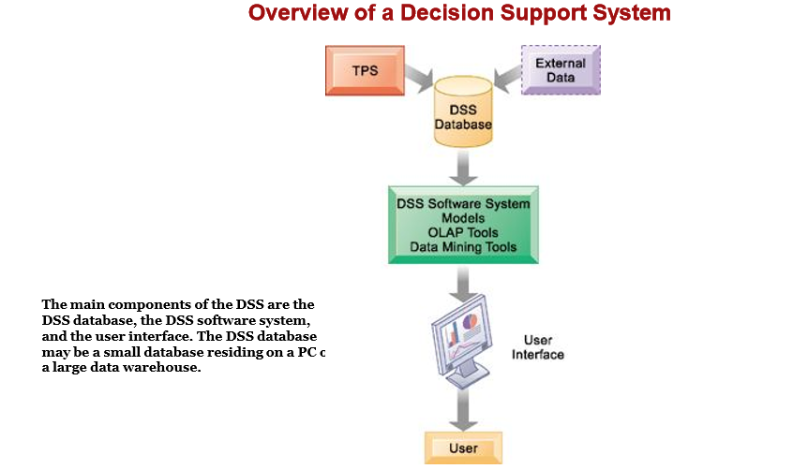

**TYPES OF DECISIONS:**

**• Unstructured :**

• Decision maker must provide judgment to solve problem

• Novel, important, nonroutine

• No well-understood or agreed-on procedure for making them

**• Structured** :

• Repetitive and routine

• Involve definite procedure for handling them so do not have to be treated as new

**• Semistructured:**

• Only part of problem has clear-cut answer provided by accepted procedure.

**DECISION CHARACTERISTICS AND EXAMPLES:**

**unstructured:**

Decide entrance or exit from markets.

Approve capital budget.

Decide long term goals.

**semistructured:**

Design a marketing plan

Develop a departmental budget

Design a new corporate web site

**structured:**

Determine overtime eligibility

Restock inventory

Offer credit to customers

Determine special offers to customers.

**DECISION-MAKING PROCESS:**

**1.Intelligence**

Discovering, identifying, and understanding the problems occurring in the organization—why is there a problem, where, what effects it is having on the firm

**2. Design**

Identifying and exploring various solutions

**3. Choice**

Choosing among solution alternatives

**4. Implementation**

Making chosen alternative work and monitoring how well solution is working

**STAGES IN DECISION MAKING:**

implementationnnn

choice

Design

Intelligence

**What is the problem?**

**What are the possible solutions?**

**What is the best solution?**

**Is the solution working?**

**QUALITY DIMENSIONS OF DECISION:**

**Accuracy**

• Decision reflects reality

**Comprehensiveness**

• Decision reflects a full consideration of the facts and circumstances

**Fairness**

• Decision faithfully reflects the concerns and interests of affected parties

**Speed (efficiency)**

• Decision making is efficient with respect to time and other resources

**Coherence**

• Decision reflects rational process that can be explained to others and made understandable **Due process**

• Decision is the result of a known process and can be appealed to a higher authority

**EVOLUTION OF KNOWLEDGE MANAGEMENT:**

KM has undergoes a paradigm shift from a static,knowledge-warehouse approach towards a dynamic communication – based or network approach focusing more on tacit knowledge.

KM is a dynamic people – centric approach especially on cultural problems and motivational issues in knowledge sharing.

**KM HAS EVOLVE FROM THE COMBINATION OF 2 FACTORS :**

1. The business world’s enthusiasm for “ intelectual capital”

2. The appearance of corporate intranet (ideal tool to link and organisation together to share and disseminate knowledge throughout scattered offices and units

**INFORMATION MANAGEMENT:**

* Focuses on information as a resource or collection.
* Practitioners select, describe, classify, index, and abstract this information to make it more accessible within and outside the organization.
* IM is concerned to provide transparent and standardized access using technology by storing and organize information.

**KNOWLEDGE MANAGEMENT:**

* Focuses on its users.
* Practioners summarize, contextualize, value-judge, rank, synthesize, edit and facilitate to make information and knowledge accessible between people within or outside their organization.
* It concerns with the social interactions with sharing and use of knowledge. KM is largely based on tacit interpretation that relate to human behavior and interchange.

**FROM INFORMATION MANAGEMENT TO KNOWLEDGE MANAGEMENT:**

1. The process of collecting, organising, classifying and dissemination of information to make it purposeful to those who need it

2. Capture knowledge in the mind of in a central repository.

3. Organising and analyzing information in a companies computer database.

4. Identification of categories of knowledge needed to support overall business strategy

5. Combining, indexing, searching and push technology to help companies organize data stored and deliver only relevant information using Intranet, groupware, data warehouse, networks, and video conferencing.

6. Mapping knowledge and information resources both online and offline

7. Knowledge assets are created through computerized collection, storage and sharing of knowledge

**KEY DIFFERENCES BETWEEN INFORMATION AND KNOWLEDGE MANAGEMENT:**

**1. Interplay Between Information and Knowledge :**

Information can easily, organized and distributed whereas knowledge resides in one’s mind (human centric)

**2. IM and KM Projects: different scopes, approaches and measurement systems :**

KM rely on the willingness of individuals whereas IM rely on technical achievements to enable information sharing

**3. Organizational Learning and KM**

Organization can learn through self-knowledge, dialogue and reuse the existing knowledge into new information

**4. Broad Concepts of KM**

Time, Context, transformations and dynamics, social space and knowledge culture technical achievement to enable knowledge sharing

**5. Protecting intellectual capital:**

IM and KM Perspectives IM used firewall, permission and access level whereas KM used retention policies and circulation of knowledge (senior to junior).

**KEY CHALLENGES OF KNOWLEDGE MANAGEMENT:**

**Security:**

Accommodating the right level of security for knowledge management is key. Conscious information should be shielded from most users, while allowing easy access to those with the proper credentials.

**Getting People Motivated:**

Overpowering organizational culture challenges and developing a culture that embraces learning, sharing, changing, improving can’t be done with technology.

**Keeping Up With Technology:**

Regulating how knowledge should be dispensed, transferring it quickly, and effectively is a huge challenge. Constantly changing structures mean learning how to be smart, quick, agile and responsive – all things a KM tool must be able to finish.

**Measuring knowledge:**

Knowledge is not something that can be easily quantified, and is far more complex because it is copied out of human relationships and experience. The focus should be on distributed purpose rather than results or efforts.

**Overpowering Shared Leadership:**

As a knowledge leader, the concerned person has the responsibility to collaborate with fellow colleagues, persuade them to share their knowledge base for the benefit of the organization.

**Keeping Accurate Data:**

It is also the basic function to keep basic data which is accurate and authentic in nature.

**ETHICS FOR KNOWLEDGE MANAGEMENT:**

* + - The study of moral obligation involving the distinction between right and wrong.
    - Business Ethics: right or wrong in the workplace – value management.

**ETHICAL DILEMMAS:**

Making decisions under stress or dealing with complex issues that have no clear indication of what is right or wrong.

**BUSINESS ETHICS MYTHS:**

* Business ethics is a new fad.
* Business ethics – religion vs. management.
* Business ethics is obvious – “do good!”
* Business ethics is good guys preaching to bad guys.

**ETHICAL TIPS FOR ORGANIZATION:**

* Develop a code of ethics.
* Communicate code and bake it into culture top-down.
* Treat ethics as a process.
* Create open lines of communication.
* Set good examples.
* Educate employees – frame issues through storytelling.
* Value forgiveness.

**BENEFITS OF MANAGING ETHICS IN THE WORKPLACE:**

* Improves society.
* Maintains a moral course in turbulent times.
* Cultivates employee teamwork, productivity, morale and development.
* Acts as an insurance policy.